Memory Card Game

**USER MANUAL**

1. **Install Pygame in your computer supported by your version of python.**

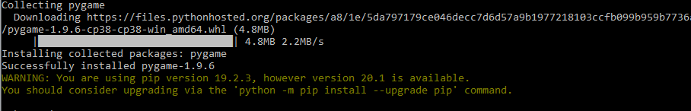

1. **Open the folder having the contents and the code written in python.**

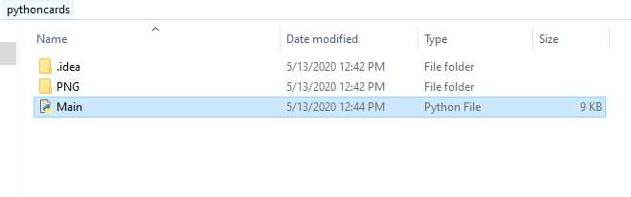

1. **Run the python code in a python editor.**
2. **The game will get started and you can see the name and operating options for the game.**

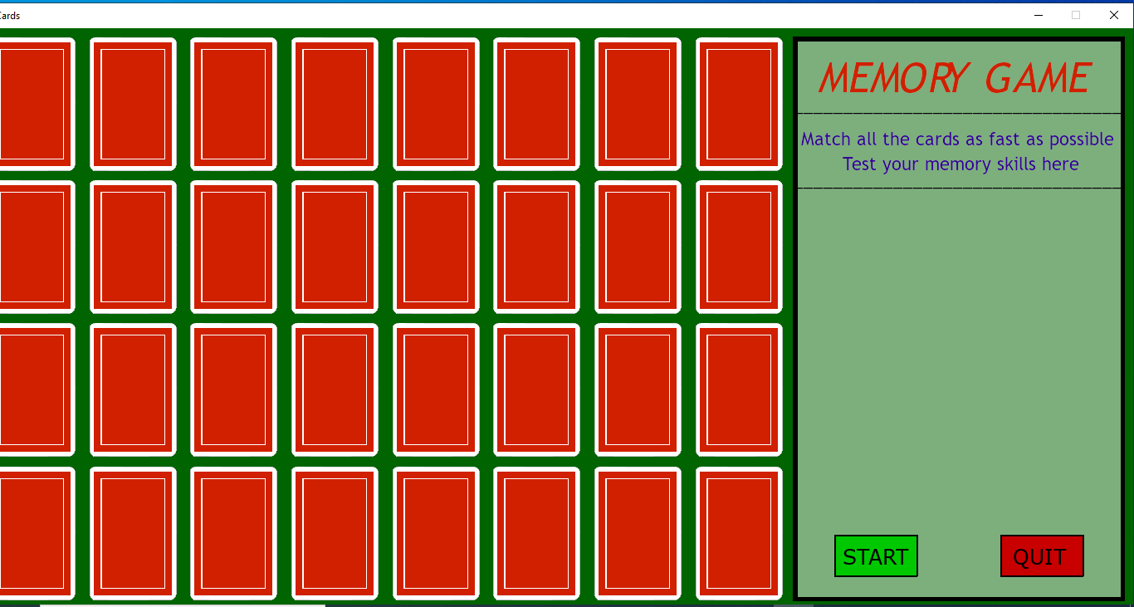

1. **Click on ‘START’ to start the game .**
2. **Keep choosing common pairs of card by clicking on the cards and remembering the last card you flipped and saw.Memorising the cards will only help to find the common card pair.**

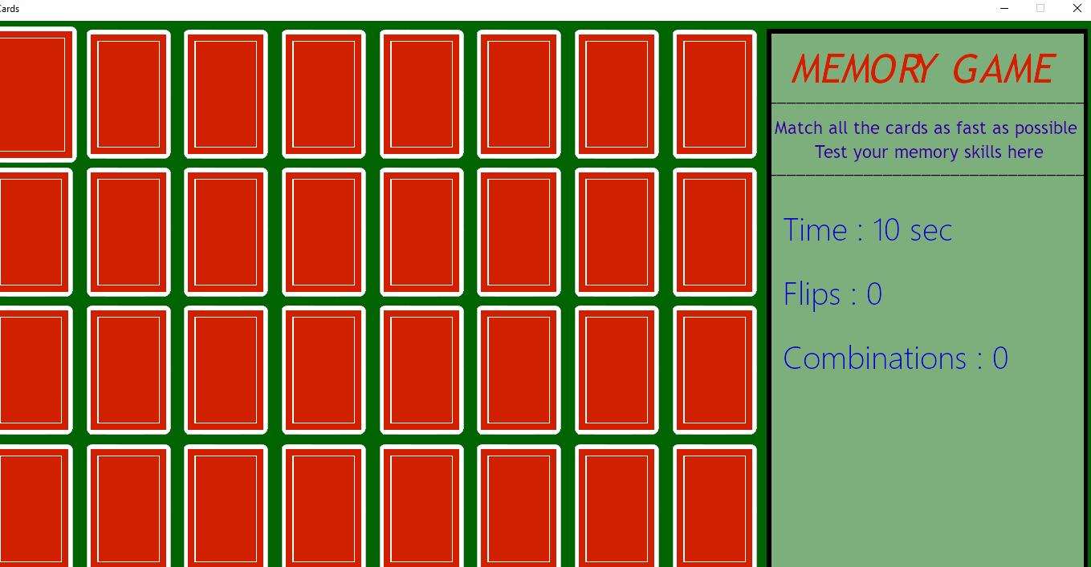

1. **Total time taken and total number of flips will be kept on increasing as you move ahead in the game.**
2. **As soon as you find the pair of common cards that pair will get removed from the cards list and the number of combinations you found will increase by 1.**

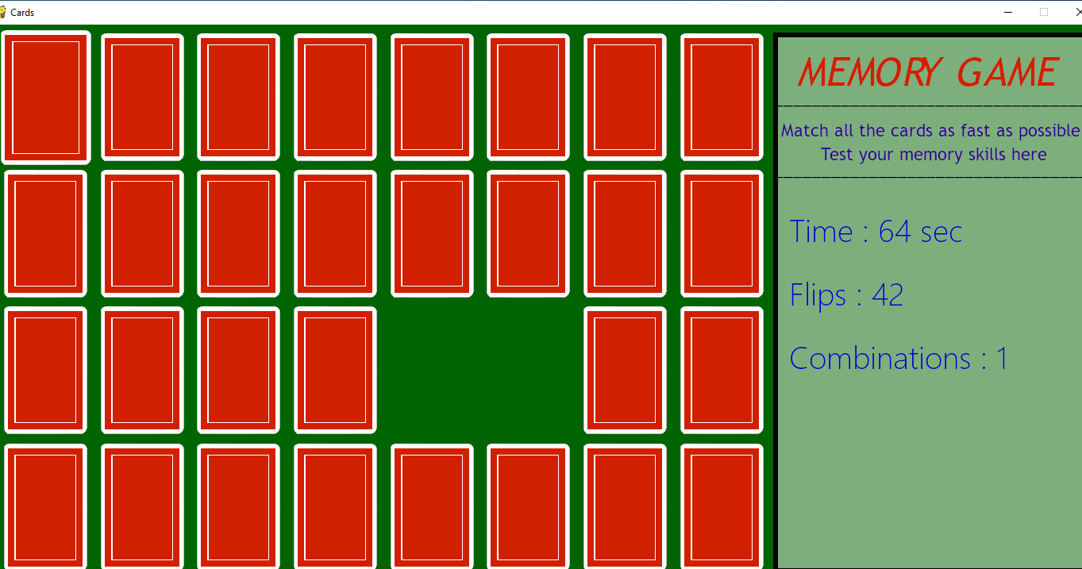

1. **Game will go on until you find all the common card pairs.**

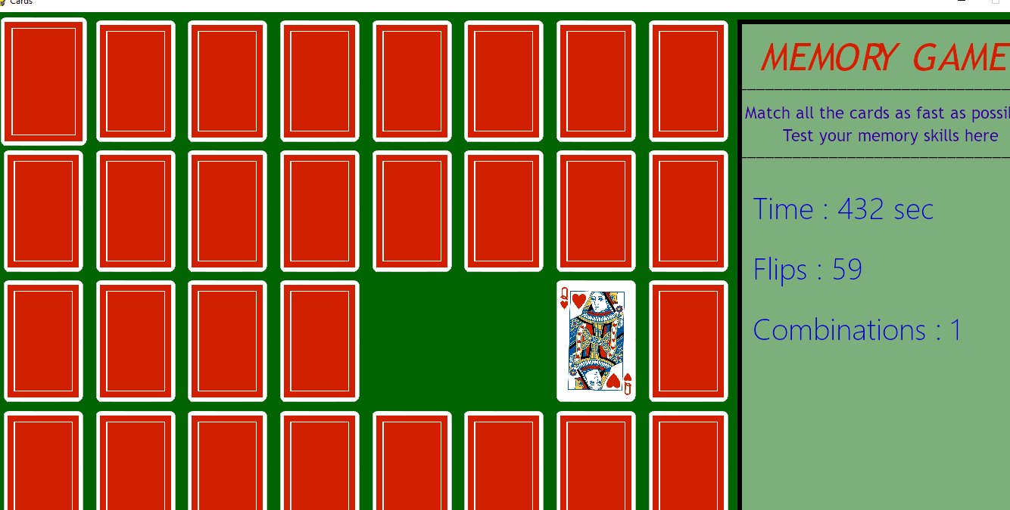

1. **After the end of the game, total time taken and total flips will be displayed and you will have two options, either to replay or quit the game.**

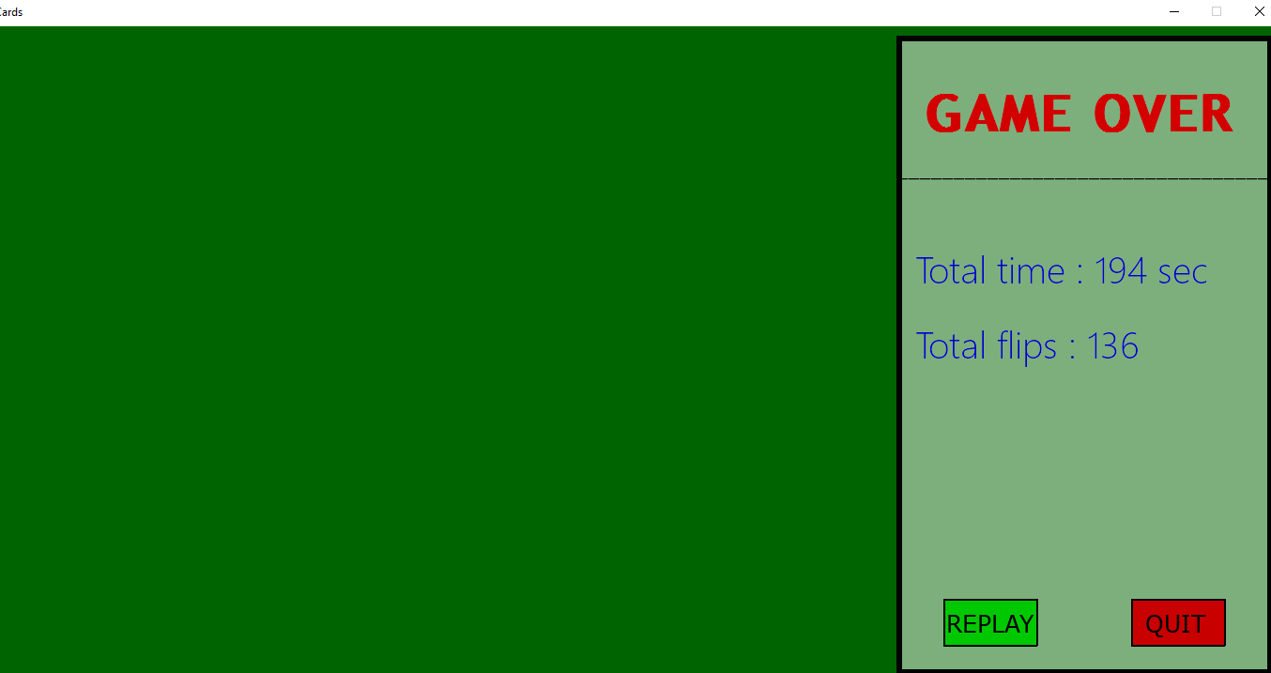

1. **If you want to play the game again, click on ‘REPLAY’ and the game will start again.**



1. **To quit the game , click on ‘QUIT’’ and the game will end.**